Based on the following document and description, create an E-R diagram for the data of

this user’s view and the domain description.

Registration clerk produces the class schedule report which is given below. Each student is sent a copy of his/her class schedule. Some restrictions, which may not be obvious from the sample data, should be noted. The advisor assigned to a student must be a professor in the department in which the student is majoring (a CIS major must be advised by a CIS professor). Course numbers consist of a 3-digit alphabetic prefix followed by 3 numeric digits. The alphabetic prefix must correspond to a valid department code.

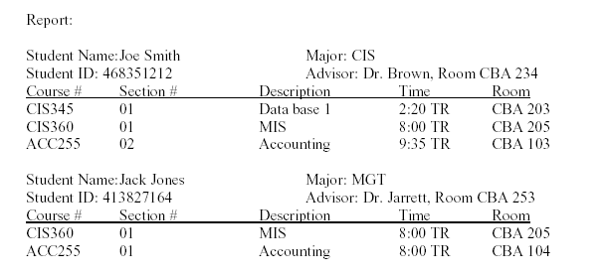

E-R Diagrams: